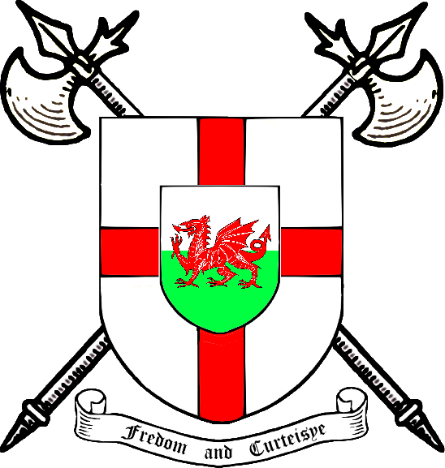 |  | Freemen of England &Wales  An association of Freemen and Guilds in England and Wales  Regd Charity 293536  Patron: The Right Honourable, the Earl Bathurst  From the President & Stephen P White,  Honorary Treasurer 11 Manor Avenue,  Great Grimsby,  North East Lincolnshire DN32 0QR  01472 329847 stevewhite.grimsby.nel@ntlworld.com

The Freemen of England was founded in 1966 by Harry Ward, a Freeman of York, in order to bring Freemen together to counter the threat of legislation which would have denied them their ancient rights and privileges.

Initially envisaged as an Association of Guilds and other organised bodies of Freemen, it soon became apparent that individuals could also benefit from personal membership by way of meeting freemen from other places and sharing experiences, receiving the Journal which is published four times a year and attending meetings and having a say in the way in which the Association is run.

The Principality of Wales was subsequently included in the title in 1992.

Grimsby has had a long association with the Freemen of England and Wales, both the Enrolled Freemen, and the Guild, being Corporate Members whilst a number of individuals hold personal membership.

I would invite you to consider joining, and have included a slip at the bottom for you to complete and return to me if you are interested.

If you wish to find out more about FEW you may visit their website at www.freemen-few.org.uk or you may contact me directly.
+++++++++++++++++++++++++++++++++++++++++++++++++++++++++++++++++++++++++++
Application Form for Full Individual Membership of the
“Freemen of England and Wales”

I declare that I am a Freeman of; …………………………………………
and have been since; …………………………………………

My cheque for the Annual Subscription (minimum £10.00 per annum) is enclosed *£ ………

*I am prepared to sign a Standing Order Mandate and a Gift Aid Declaration – please supply forms
* delete as appropriate

Name…………………………………………………………………………… Date of Birth …………………

Address…………………………………………………………………………………………………………...

……………………………………………………………………………………………………………………..

Post code……………………Tel No ……………………………………Occupation ………………..............

Email……………………………………………………………………… Date ………………………………..

Please return this form to Stephen White, at the above address.
Please make cheques payable to “Freemen of England and Wales”

