Great Grimsby Guild of Freemen
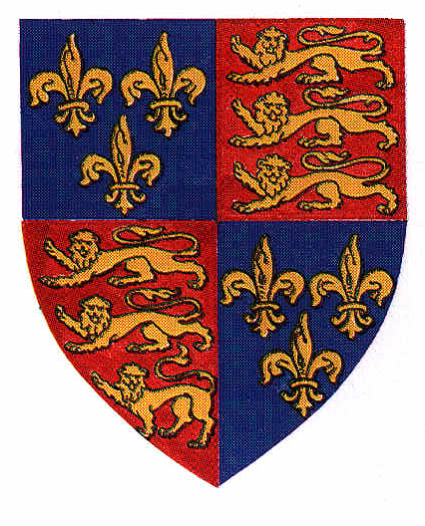

The Great Grimsby Guild of Freemen was founded in 1978 by the then Chairman of the Pastures Committee, Edmund T. Ellis. The idea was, as in other towns and cities, to provide a forum for Freemen to meet socially and to learn about their heritage and other subjects of local interest. The Guild, which has its own Constitution, receives no financial support from the Pastures Committee but manages its own affairs through a very modest membership fee and other fund-raising activities. Since its formation, the Guild has organised many social events, annual dinners and exchange visits with Freemen from elsewhere. We have also hosted the Annual Meetings of the Freemen of England & Wales on three occasions, the most recent being in 2001. Sadly, since then, the Guild has not been very active owing to falling membership numbers and difficulties in recruiting Court members. I am hopeful that, given the recent publicity and raised profile that the Freemen are enjoying by way of the Freeman Street Regeneration project that we are involved in, the on-going improvements to our market, and the Admission of Women to the Freedom, that the time is now right for the Guild to become active once again. If you are interested in joining, would you please complete and return the slip below. No monies will be banked until I am satisfied that there is sufficient interest for the Guild to properly function so that payments may be returned if necessary. Hopefully, there will be the interest and in which case I will write to those individuals who respond and arrange a meeting so that we may properly organise ourselves.

Thank you.

Stephen P. White, Master & Chamberlain
11 Manor Avenue,
Great Grimsby,
North East Lincolnshire,
DN32 OQR

Tel No Grimsby 329847
Email stevewhite.grimsby.nel@ntlworld.com

************************************************************************************************************************
Great Grimsby Guild of Freemen
Membership Application 2019/20

Full Member (one whose name appears on The Pastures Roll) # £3.00
Associate Member (Spouse or partner not on The Pastures Roll) £1.50
Senior citizens - half of the above

Name………………………………………………………………………FM/AM/Sen. Citizen £…………

Name of spouse/partner…………………………………………………FM/AM/Sen. Citizen £…………
(if applicable)
Address…………………………………………………………………………………………………………

……………………………………………………………………………………………………………………

Post code……………………Tel No ………………………………………

Email…………………………………………………………………………

# We also invite applications from those who otherwise qualify for admission but live outside of the Borough

www.enrolledfreemenofgrimsby.org

